|  |  |
| --- | --- |
|  | **2013** |
|  |  |

|  |
| --- |
| **[Intro to raspberry pi]**  by Judy Matar |
|  |

Contents

Why Pi 3

Success 3

How to buy a rpi? 4

Specs 4

GPIO PINS 5

Setup 5

-Distros 6

-Visual 6

Comparison 6

-Model A vs model B 6

-Rpi vs UDOO 6

-rpi vs beagle bone 6

Rpi vs Arduino 8

Demos 9

Project Ideas 9

videos 10

-brickPI 10

-led cube 10

-supercomputer 10

-microscope 10

-mix 10

What does it all mean? 10

one more thing... 10

# Why Pi

## Success

The raspberry pi was created with the primary goal of teaching computer programming to children. It was developed by a UK registered charity: the Raspberry Pi Foundation, with its founder EBEN UPTON .

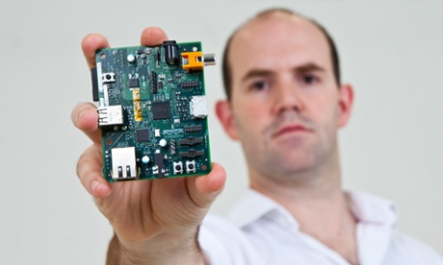

Figure1 - Eben Upton: The founder of rpi foundation

Eben Upton is a professor in the University of Cambridge. He was responsible about recruiting new students in the department of computer engineering. Due to his expertise in the field, he noticed a very big difference between students of his time and students nowadays. A decade ago, students were obliged to know the basics of programming and electronic engineering. For example he cites a situation that happened to him as a child and left a mark on his carrer; when the mouse was first introduced into the market, he purchased one, then coming home he plug it in his PC via USB cable and waited. Nothing happened. Calling the tech support, he got the outrageous answer: "If you don't know how to write a driver for the mouse, then you don't deserve to own a mouse."

That's the difference between a generation expected to know programming and where each computer owner had a vast good understanding of how computers works and a chance of becoming a programmer ; and a generation that has access to all the FOSS(free open source society) but rarely crosses the line to learn due to the machines like tablets and gaming consoles that are completely unprogrammable.Also there's a lack of cheap programmable devices, so everyone are spending times using the software like they are playing in a wonderful playground and they never bother to find out how it works, or to program anything..

That's why the Raspberry Pi was invented. It's main goal was to promote the study of computer science and related topics, mainly in schools, and to put the fun back into learning computing. And it was a big success: Rpi was put in the market in February 2012; sold 100,000 pi's on the first day. and just three weeks ago the sales of raspberry pi have hit 2 million.

For the first time it's accessible for school collages and hobbyists to have some fun and get inspired to get into science and engineering by starting with cheap and simple, to then go to do much more complicating things and to program computers for themselves.

The big surprise to the company was that a large number of adults, computer geeks were interested in the Rpi and have made amazing projects that exceeded the expectations of the Rpi foundation. So now the device is expected to have many other applications both in the developed and the developing world.

## Buying a Raspberry Pi

The official suppliers of Rpi are RS components and element 14 by farewall. But of course being a Lebanese citizen can cause us few trouble to get your hands on a rPi. Now it's available in Tripoli with Mr. Rami Nassou7 , as it's many accessories.

The raspberry pi costs about 35$ from the official website. Noting that it's on high demand and usually out of stock , plus the first rpi sold was actually put in auction and was sold for 1000 times it's actual price! That shows how successful the rpi is.

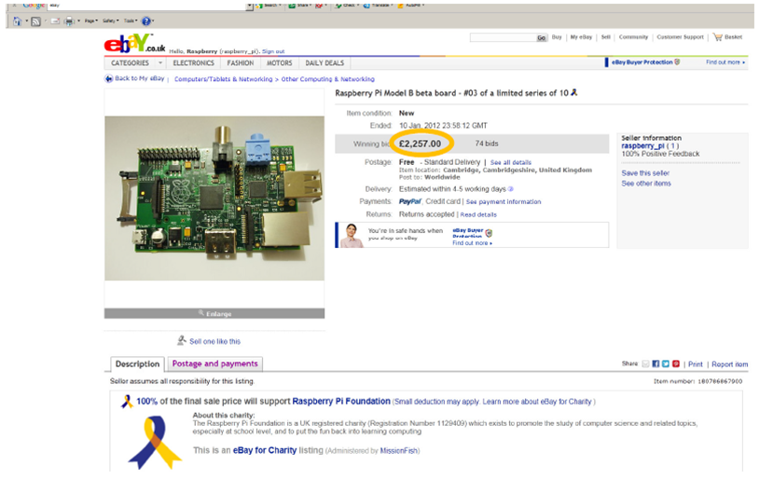

figure1- The first rpi selling price

Many accessories are made now specifically for the rpi. and one of them is the case, which is just for protection. As the first rpi was not expected to sell as many as it did the company didn't make any cases for it; but 2 startup companies, 2 unfunded startup companies in UK turned over a million pound each in the first year making rpi cases. So manufacturing jobs have been created by the rpi , for example a 20 year old student Jake march have gone millionaire by scrapping off enough money to create a molded design of a rpi case.

# Specifications

The Raspberry Pi (short: RPi or RasPi) is an ultra-low-cost ($25-$35) credit-card sized Linux computer .

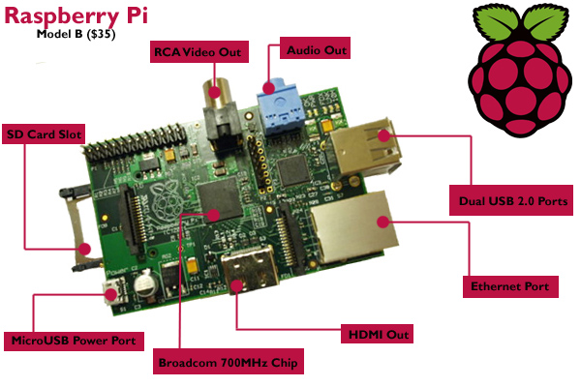

Figure 1 - Specs of rpi

It's a complete 700 MHz ARM CPU with a GPU and 256MB of RAM. It has two USB ports, Ethernet, Audio as well as video out over RCA (Composite) or HDMI at 1080p. It uses an SD Card for its hard drive and takes 5V at >700mA of power over a mini USB.

At its heart is an ARM chip, like that found in mobile phones and tablets, and it runs a version of the free open-source operating system Linux found in many web servers and in Android smartphones.

* The Raspberry Pi is a Broadcom BCM2835 system on a chip (meaning, for these purposes, a bare circuit board), which unites a 700MHz ARM1176JZF-S CPU with a Broadcom VideoCore IV GPU, and 256MB of SDRAM. Those USB 2.0 ports are your only external data connectivity options, although there are two video outputs in the form of composite RCA and HDMI ports, a 3.5mm audio output, and an SD/MMC/SDIO card slot that is the extent of how you can access storage. The Raspberry Pi is powered via a micro USB adapter, with minimum ratings of 500mA (2.5 watts) for the Model A and 700 mA (3.5 watts) for the Model B, any mobile charger can be used, which emphasis the idea of a cheap device. Its measures are about 0.6 by 2.1 by 3.4 inches (HWD), which is not much bigger than a credit card
* **supports 1080p video**- which makes it better than the beagle bone black, since it outputs video and can be used as a media center.
* **easy to overclock**- The raspberry pi is easily overclockable. you can take it from 700Mhz to 900Mhz just by running the following command:  
  $ sudo nano /boot/config.txt   
  and changing arm_freq=700 to arm_freq=900 also adding sdram_freq=500.

Be aware that "overvoltage" will void the warranty .

* **It's a full blown Linux machine** - The raspberry pi is a microcomputer, since it has a microprocessor in it ( not a microcontroller such as the arduino). So it can have a distribution of Linux installed on it and used as a complete computer. Just attaching a screen, keyboard and mouse will make it a linux computer.
* **It's a Media Center** - One of the distributions of the linux is RaspBMC wich is an XMBC fork. It's an open source media center system which runs on the raspberry pi turning it into a video, audio player.
* **Coding Device** - The raspberry pi might have distributions that make it seem as a closed computer, but we shouldn't forget that it's a board with pins and debugging software. It mainly runs Python and the Raspbian default distribution of Linux includes Python 2 and Python 3 IDEs and is easy to script; but the rpi can also run any language since it is a tiny ARM machine such as Mono and .NET.

The pins of rpi support many protocols: GPIO,UART,I2C, and SPI.

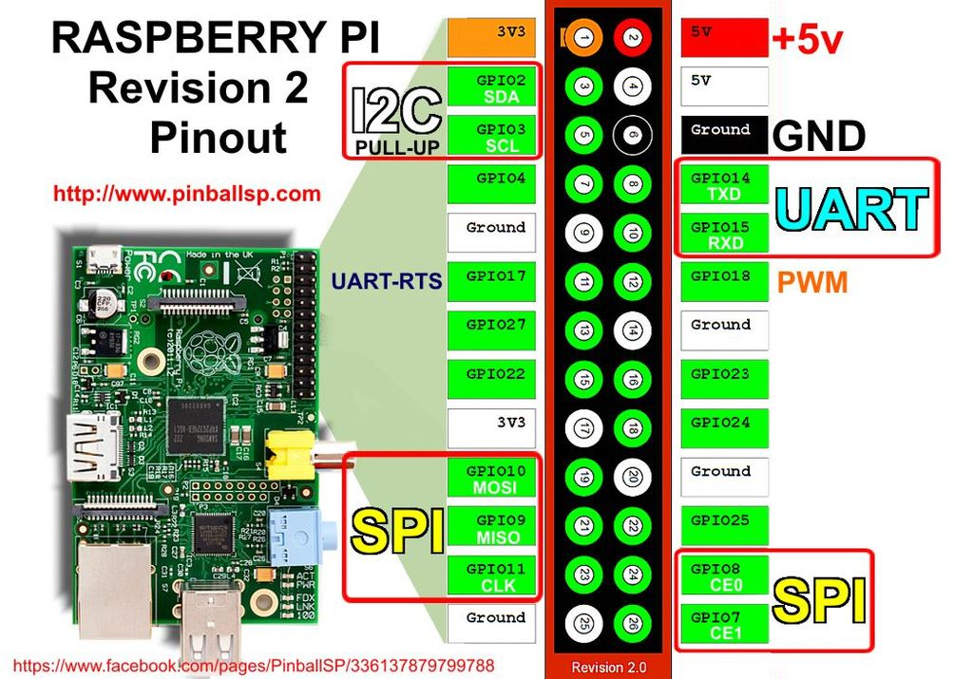

figure 1 - Pinout board of rpi

# Comparing Hardware Hacker Prototyping Boards

## -Model A vs. model B

The raspberry pi comes in two moddels: Model A (for $25) and Model B ($35). There is two main differences between the models:

First: model A has one USB port , model B has two USB ports

Second: model A doesn't have an ethernet port; whereas model B has an ethernet which affects the power usage -Model B uses almost half as much power as the Model A.

## Rpi vs. Arduino

Arduino is the true trailblazer in the **microcontroller** area and the device that started the whole “maker” revolution; the Raspberry Pi on the other hand is an amazing device that really started the **microprocessor**revolution.

The $25 Arduino is a staple of the DIY community because it's open-source, easy to develop for, consumes very little power, and is very simple to set up. Plus, it’s designed specifically for beginners, so pretty much anyone can play with it and connect it to external components. Essentially, the Arduino is a small, programmable board that accepts and stores code from your computer. It's capable of simple, but cool things like controlling lights or programming gardening systems. The board, the programming language, and most projects you find are open-source so you can use them to suit your own needs.

We've walked you through the basics of getting started with Arduino before, and it's easy enough that pretty much anyone can do it. If nothing else, the Arduino is a perfect starting point for anyone looking to get into DIY electronics because it's very easy to use and hard to mess up.

**Advantages**: At $30, the Arduino is cheap enough that you can buy a few to mess around with. Alongside the flagship Arduino Uno, you have a ton of other variations of the Arduino to choose from. The Arduino also consumes very little power, so it's perfect for projects that run all day long, or need to be powered with batteries. Most importantly, the Arduino is insanely popular, so it's easy to find support, tutorials, and projects. Finally, the Arduino is flexible and can interface with just about anything.

**Disadvantages**: The Arduino is a beginner board, but it still takes a little while to get used to using something without a graphic interface. Because it's cheap and small, the Arduino can't usually handle a lot of different processes at once, so it's not good for projects that are incredibly complicated or require a lot of computing power.

**What the Arduino is best for**: The Arduino is best suited for single-purpose projects. Say, a system where your dryer sends you a text message when your clothes are done ora video doorbell system. The Arduino is also really well suited for interacting with objects in the real world, so if you need to interface with something like window blinds or a door lock the Arduino is a good place to start. So, if you're designing something simple like a control panel for a garden, an Arduino is perfect. If you need that control panel to connect to the internet, have a multi-touch display, and feature full automation, the Arduino probably won't work.

The $35 Raspberry Pi has been a DIY-darling since it was first announced. It's essentially a tiny computer that runs Linux from an SD card, and from there you can run all sorts of DIY projects. It's essentially a low-powered Linux computer, and subsequently can do anything a Linux machine can for only $35. With the two USB ports and the HDMI out, you can use the Raspberry Pi just like you would any computer, and that means it's perfect for all sorts of projects that require a Linux system.

Subsequently, the Raspberry Pi is good for anything you're making that requires a display, and especially any projects you want to connect to the internet. Remember, it's basically a tiny computer, so provided you're not looking to do anything super complicated with it, the Raspberry Pi can handle a ton of different things.

**Advantages**: Being a tiny computer comes with all kinds of advantages. For one, the Raspberry Pi's HDMI port means it's easy to plug into a TV, and the two USB ports make it so you can operate it like a computer with a mouse and keyboard easily. It also has an Ethernet port built in, so you can easily connect to the internet with little hassle. Since the operating system runs off a SD card, you can also change operating systems easily by simply swapping out the card. This is pretty handy considering you have a few options for the operating system. For the price, the Raspberry Pi is powerful but still easy enough for beginners to use.

**Disadvantages**: The Raspberry Pi is awesome for just about any project you'd use a computer for, but unlike the Arduino and Beagle Bone, it doesn't have as many options to interface with external sensors or buttons. So if you want to do a project that's interfacing with other electronics in your home, or lights around the house, the Raspberry Pi isn't quite as solid of an option.

## -Rpi vs. beagle bone

* **WHEN THE BEAGLEBONE BLACK IS THE RIGHT CHOICE**

the Beagle Bone Black is priced at a very affordable $45.

The easiest way to describe the Beagle Bone Black is as combination of a Raspberry Pi and an Arduino. It has the power of the Raspberry Pi, but it has the external interfacing options of the Arduino. At $45, it's right on par with the cost of either, but it manages to do enough things differently that it's in a world of its own.

Since it doesn't actually require a display like the Pi to setup, the Beagle Bone Black is targeted more at advanced users and serious developers. Still, it has the Angstrom Linux distro installed from the start, so like the Pi, you can use it as standalone computer if you like. You can also install a wide variety of other operating systems, including Android. The Beagle Bone Black is a tougher system to get used to than the Raspberry Pi because it wasn't initially targeted as an education system, but you can do a lot with it.

**Advantages**: The Beagle Bone comes packed with flash memory and an operating system already installed, which means that out of the box it's already fully operational. If you want to run in headless mode (without a monitor), it's easy to do, and you don't need extra hardware to set it up like you would with the Raspberry Pi. The big advantage for the Beagle Bone is that it has a really good set of input/output features (69 GPIO pins compared to the Raspberry Pi's eight) so it can interface with exterior electronics easily.

**Disadvantages**: The Beagle Bone doesn't have as many USB ports as the Raspberry Pi, nor does it have video encoding built in, so it's not really that great as a standalone computer or entertainment system. It also doesn't have quite the same amount of fervor around it as the Raspberry Pi, so while the community around the Beagle Bone is strong, it's not nearly as loud as the Raspberry Pi. That means tutorials and project ideas are a little harder to come by.

**What the Beagle Bone is best for**: The Beagle Bone is best suited for projects that might be a little too complicated for the Arduino, but don't need any complex graphics like the Raspberry Pi. Since it connects to the internet out of the box, it's a lot cheaper to use than an Arduino, and since it has a ton of ways to connect external sensors it's perfect for advanced projects that interface with the real world.

**Projects that need to interface with many external sensors** – The incredible number of pins on the Beagle Bone Black and the many bus options allow you to easily interface with pretty much any device out there.

**Anything requiring small form factor but high speed processing** – For example this super cool 33 node Raspberry Pi computing cluster would have been much better off using the Beagle Bone Black, both from a price and performance standpoint.

**Projects that you may wish to commercialize** – Since the Raspberry Pi is more of a closed-source environment, it is impossible to make your own minimal versions. The open nature of the Beagle Bone would allow you to just take the most important features and directly port that into your own design.

**As an embedded system learning platform** – The Raspberry Pi has its roots in education, but the fact that the Beagle Bone Black works out of the box leads me to believe it is a better solution for learning about embedded systems.

**For when you want it to “just work”** – The fact that the Beagle Bone Black works right out of the box is a huge bonus and allows you to get up and going in a few minutes rather than an hour or more.

* **WHEN THE RASPBERRY PI IS THE RIGHT CHOICE**

**Multimedia based projects** – With the significantly more powerful graphics processing and larger number of connection options, the Raspberry Pi is a no-brainer for multimedia interfaces.

**Community driven ideas** – If you have a project that will in some way rely on the community for proper operation, you should choose the very active community of the Raspberry Pi. If you just think you will need support though, the Beagle Bone community is very helpful and many Raspberry Pi projects will easily port to the Beagle Bone Black.

**As a graphical learning platform** – Since the Beagle Bone Black does not have quite the video capability of the Raspberry Pi, I would recommend the Raspberry Pi for learning about Linux in a graphical environment. Though to be fair you could do the same thing in a Virtual Machine, it just isn’t quite as much fun.

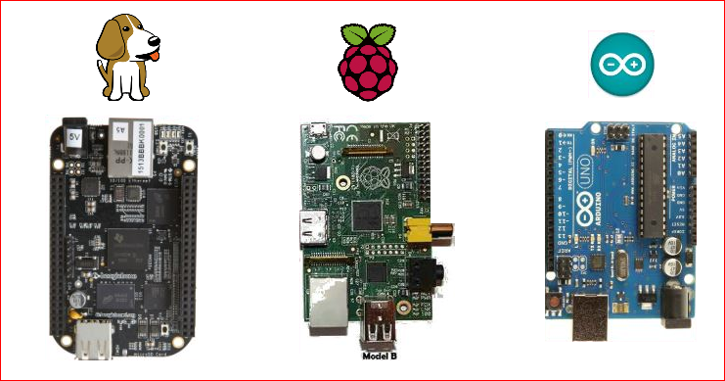

figure1 - Beagle bone Vs. Rpi Vs. Arduino UNO

# Setup

Setting up the raspberry pi is consisted of many parts:

1-Connecting to Power supply: The rpi connects to power via 5V micro-USB adapter, but be careful cause the Pi needs power at at LEAST a 5V and 700mA, and to make sure you have enough power you should measure the voltage between tp1 and tp2 using a voltmeter to check that it's between 4.85 and 5.2 volts. This might seem like an easy step but it actually caused us a lot of trouble working in our project using raspberry pi, since we started powering the rpi with an HTC charger , we experienced lots of misbehaving from the hardware: screen freezing, keyboard malfunctioning, internet disconnection.. And after looking through forums and troubleshooting we measured the voltage tp1 and tp2 and found out it's much less than the required so we replaced the power supply several times until we get a decent one powering the rpi.

2- Installing a Linux distribution

Many Linux distribution has been made available by the FOSS - free open source society. The distro is the brain of the rpi, it is useless without its operating system. And the way to set it up is by installing the desired distro on an SD card and then inserting it into the SD card slot in the rpi. The Distros are available on the rpi official website for free download www.raspberrypi.org . Once downloaded, install it on an SD card of 4 GB minimum storage using win32diskimager-v0.7 for windows, also available for free download. And now there is a new out of the box software "NOOBS" which only needs formatting the SD card and downloading and unpacking the NOOBS zip file onto the SD card.

The main distros of the rpi are:

2.1-  Raspbian: Raspbian is a free operating system based on Debian. Website: http://www.raspbian.org/ It is optimized for the Raspberry Pi hardware. Raspbian is a complete operating system which is the set of basic programs and utilities that make your Raspberry Pi run as any computer. Raspbian is the most used distro for the rpi and it is the officialy recommended one from the rpi organization. It has python IDEs and opens up a lot of opportunities for software and hardware development. If raspbian is installed, a screen connected, and a keyboard, you get a rpi based computer. Just as easy as that.

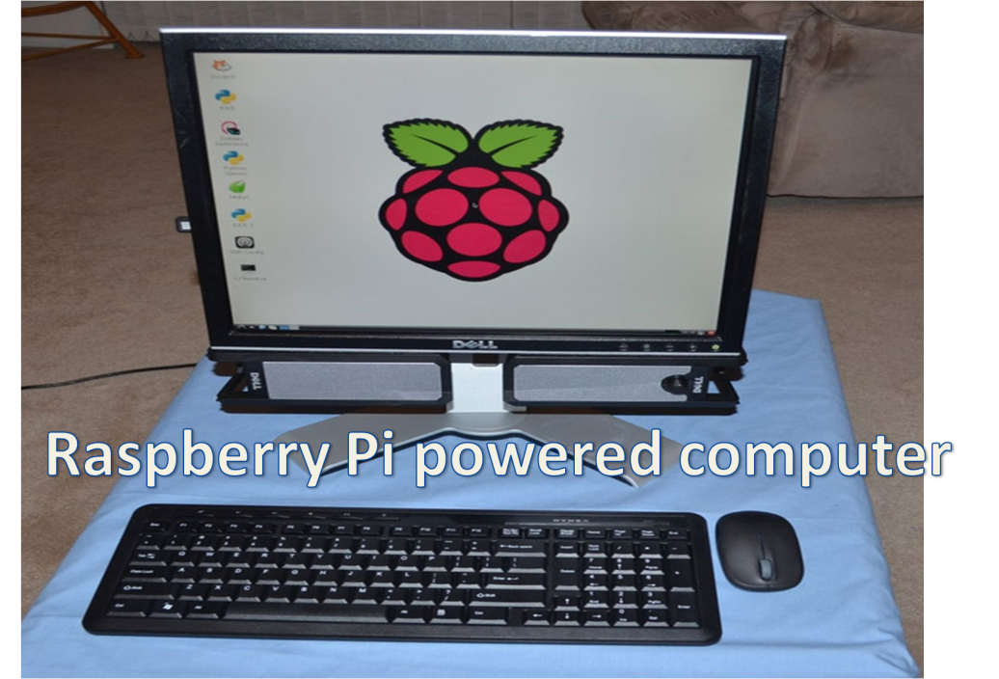

figure1- rpi powered computer

2.2- RaspBMC : RaspBMC is a simplistic yet powerful Raspberry Pi media center distribution, created by Sam Nazarko. Website: http://www.raspbmc.com/ .With RaspBMC you can make use of any old screen you have laying around, whether it is an old computer screen or an old tv, even better if you use it on a new lcd tv since the remote is compatible with raspbmc - if you ever wondered what the buttons in the center of your remote are used for, well this is it! With its official remote on android market and apple store appstore you will be able to control your tv using your phone. Also with many plug ins available in the RaspBMC such as YouTube and Garfield you will have everything you desire straight from the internet to your tv. It's a smart tv that only costs you an extra 35$ instead of thousands of dollars . Plus since the rpi has a USB port, you can use rasbmc as a dvd player that allows you to watch movies straight from your external hard drive. Many options are available to give you an amazing experience and let you make use of your old screen. For example you can set up a slide show of your pictures and play your favorite track in the background, having this way a smart display on your tv instead of turning it off. As if it's not awesome enough, it has AirPLay support so a RaspBMC-running Raspberry PI can be the easiest and cheapest way to watch wireless video on your giant TV from your iPhone or iPad. It doesn't support MPEG2 but it supports MPEG4 and h.264.

For the purpose of testing the raspbmc , we have installed it on two sd cards, one to try it in the lab of the university, connecting it to an old computer screen

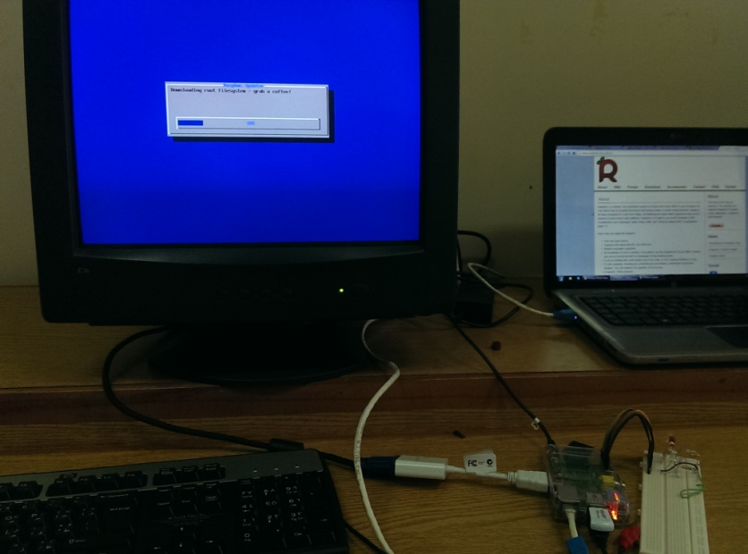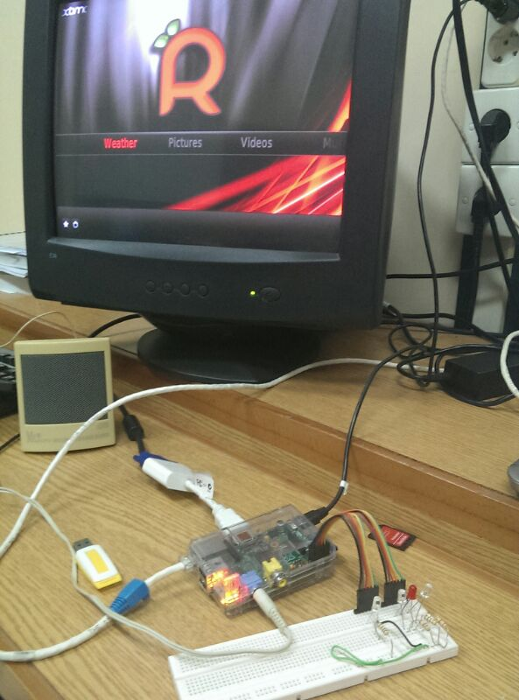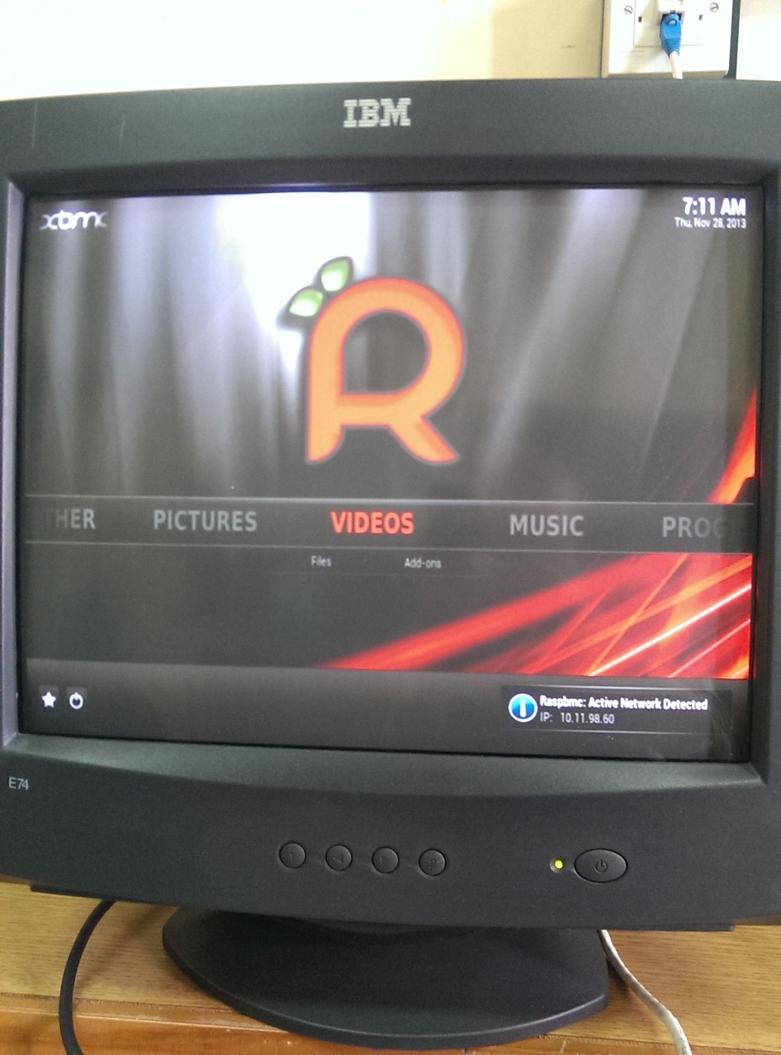

Other try out of the raspbmc was on an LG tv, where we tried the remote which worked perfectly on it, plus the remote software from the android market which also gave us great easy control.

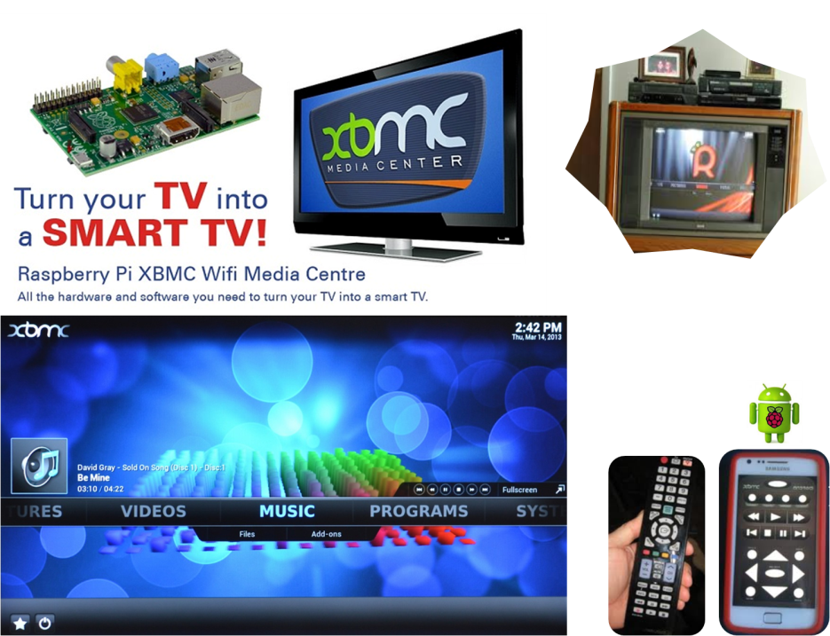

2.3- Other distros are available such as :

RISC OS: a very fast and compact system

ARCH: An Arch Linux port for ARM devices

OpenELEC : a fast and userfriendly XBMC Mediacenter distribution.

Pidora: a Fedora Remix optimized for the Raspberry Pi

3- Connecting a screen for the visual output

In order to have a visual display there are three methods:

-HDMI output: directly connected to a tv with HDMI input. Great for obtaining video and audio output together.

-HDMI output + HDMI to VGA convertor : Ideal to use computer screens. In our project we used this method in the lab.

-RCA output : The rpi has an RCA output because it follows the law of "use the leftover hardware laying around your house". So since many old tvs have RCA inputs, the rpi was manufactured with RCA output.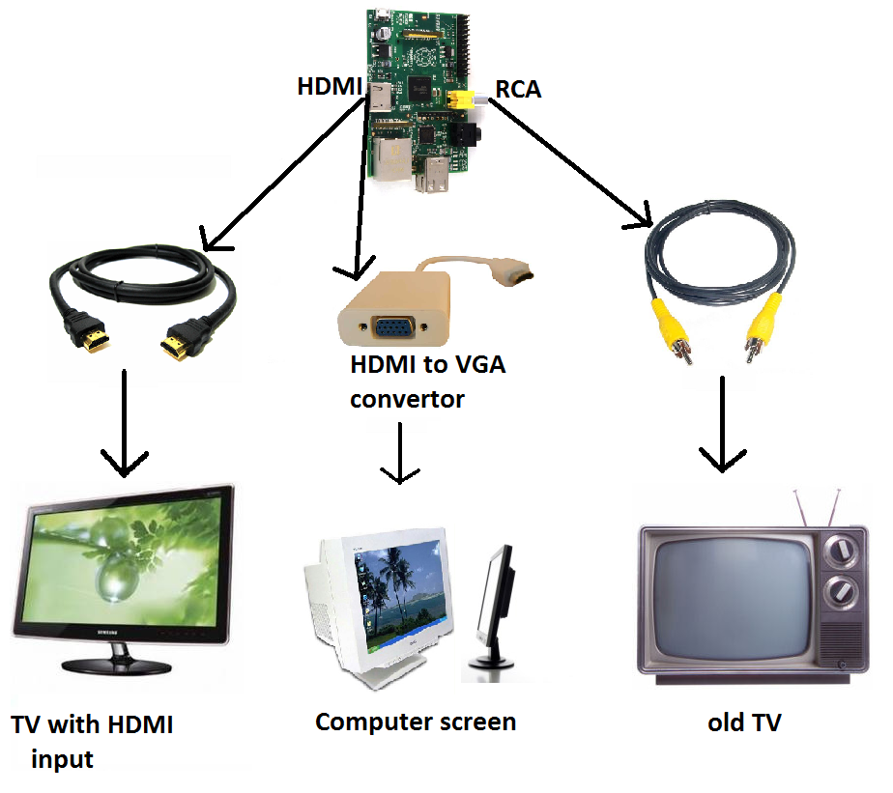

figure1- display of rpi

4-Various connections: connecting a mouse and keyboard using a powered usb hub , connecting to internet via wifi dongle usb or via Ethernet port, expanding the pin board to a breadboard (optional), adding a camera module (optional), and adding a touch screen (also optional). The most important thing to do before buying any accessory for the pi is to check all the parts against the Raspberry Pi Verified Peripherals list.

5- Startup and static ipadress

**Using a static IP address**

By default the **Raspberry Pi** is set up to obtain an IP address from your wired or **wireless network** automatically.

This method of obtaining an IP address is called referred to a **dynamic IP**or **DHCP**. The IP address for your Raspberry Pi is much like a house address. Imagine that a postman needs to deliver a package. He will read the address on the package and deliver it to the house number, in a street and in a particular area. When information is sent to your Raspberry Pi it needs to know which Raspberry Pi to send it to. Your Raspberry Pi must have an IP address so that it can receive this information. An IP address looks something like this.

**192.168.100.1**  
**10.10.1.1**

We need a **static IP address** if you want to connect to your Raspberry Pi. The DHCP method will change your Raspberry Pi’s IP address almost every time you restart which can cause a problem if you are connecting to it using an IP address of 192.168.100.1. At the next reboot, it may change it to 192.168.100.2. In order to do this we need to edit the interfaces file. Enter the following command in the terminal window.

**$ cat /etc/network/interfaces**

This will list the network interfaces available.  
**iface lo inet loopback**  
**iface eth0 inet dhcp**

This file currently reads ‘iface’ meaning interface followed by ‘eth0’ which is you’re the built in network connection on your Raspberry Pi. Next we have ‘dhcp’ which means that we want to use DHCP to obtain an IP address.  
Let’s edit the following file so we can use a static IP address.

Enter the following command into the terminal window.

**$ sudo nano /etc/network/interfaces**

This will allow you to edit the file using nano.  Change the line that reads

***iface eth0 inet dhcp*** to ***iface eth0 inet static***

Below this line enter the following.

**address 192.168.100.1**  
**netmask 255.255.255.0**  
**network 192.168.100.0**  
**broadcast 192.168.100.255**  
**gateway 192.168.100.254**

I have used my network settings but you will need to find out your network settings of your own network. I will list the main points in this file. The IP address of 192.168.100.1 is the address I am giving the Raspberry Pi. The network is the network identification that we are using and the gateway is 192.168.100.254. The gateway is important and in most cases will always point to your firewalls, switch or routers IP address. All traffic from your Raspberry Pi will exit your network via the gateway.

Enter the follow **$ sudo reboot**

Your Raspberry Pi should now have a static IP address. To test this log back into your Raspberry Pi and at the terminal enter

**$ ifconfig**

You should see a line that reads

***eth0 Link ………***  
***inet addr:192.168.100.1 ……..***The ‘inet addr’ should be the IP address that you have assigned to your Raspberry Pi. To confirm that this is true you should ping your Raspberry Pi from another PC or Raspberry Pi. If you ping the IP address you have assigned to your Raspberry Pi and you get a reply then everything worked as planned. Note that the Raspberry Pi or computer you are pinging from must be on the same network range. For example your PC’s IP address must be 192.168.100.2, 192.168.100.3, 192.168.100.4 and so on.

You can also ping your gateway from your Raspberry Pi to check that the Raspberry Pi being recognised on your network.

**$ ping 192.168.100.254**

6- Setting up SSH connection

Although the raspberry pi works as standalone when connected to a screen, keyboard and mouse, it's not very practical to have a big screen laying on your desk and your laptop next to it. Plus since it has a relativley small RAM

-web server: One of the more basic things that those with a little programming experience can do with Raspberry Pi is set up a personal web server. The microcomputer won't be able to handle any major traffic, but it will do nicely for hosting a resume or personal landing page or even a little Dropbox clone with no monthly fees.

* Automate everything in your home